Broadcom’s total AI-related orders on hand exceed $73 billion, nearly half of the company’s consolidated $162 billion backlog. The $73B backlog is expected to ship over the next 18 months. This backlog includes not only XPUs but also networking components. Most of the earnings call was management explaining the $73 billion is a baseline for the next 18 months.
Notably, there’s been a significant amount of hype around custom silicon challenging Nvidia, thus, the bar was set high going into this earnings report. For Broadcom, the words “steady as you go” come to mind.
Next quarter, AI revenue is expected to double year-over-year to $8.2 billion. During fiscal year 2025, AI revenue grew 65% year-over-year to $20 billion, leading to semiconductor revenue seeing an all-time high of $37 billion. During the fiscal year, the Infrastructure Software segment posted 26% growth to $27 billion, led by strong adoption of VMware Cloud Foundation, which represents enterprise software monetization.
Management emphasized that AI has now grown more than 10x over the past 11 quarters, illustrating how rapidly Broadcom has scaled this business. Custom accelerators, or XPUs, more than doubled year-over-year, primarily driven by Google’s TPUs as Big Tech now turns toward monetizing their platforms through inference APIs and AI-driven applications.
The report was fairly neutral as Broadcom struggled to live up to the recent custom silicon hype; yet it’s also clear Broadcom is in pole position to be a large beneficiary of the incoming AI Monetization Supercycle. You can view my free coverage here, where I connect the dots on why the AI trade’s best years are still up ahead.
Regarding this earnings report, the main topics can summed up by the expanding customer list, the margin compression expected from XPUs, and the strength of Tomahawk 6.
$73 Billion Visible Backlog and Expanding Customer List
In the opening remarks, Hock Tan provided an update on the backlog, stating “And all these components combined with XPUs, bring our total order on hand in excess of $73 billion today, which is almost half Broadcom's consolidated backlog of $162 billion. We expect this $73 billion in AI backlog to be delivered over the next 18 months. And in Q1 fiscal '26, we expect our AI revenue to double year-on-year to $8.2 billion.”
The earnings call was essentially a series of questions dissecting this statement. Overall, Tan implied this is more of a baseline, stating: “And obviously, this is as of now, I mean, we fully expect more bookings to come in over that period of time.”
Broadcom has an expanding customer list that is quite impressive, including Google, Meta, Bytedance, Anthropic and now a fifth customer (analysts asserted the 5th customer is OpenAI, management declined to comment). The fourth customer, Anthropic, placed a $10 billion order for the TPU Ironwood racks with an additional $11 billion placed in the latest quarter. In the earnings call, management made sure to state they are building server racks for Anthropic and not only chips – stating it was “a system sale.”
The market is suddenly taking notice of custom silicon (despite it being debated as a risk to Nvidia for over a decade) because an R&D lab is turning to TPUs and also now that Ironwood v7 is the first generation of TPUs to be specifically designed for inference.
Tomahawk 6
Broadcom’s Tomahawk 6 is an Ethernet switch built to address the scaling limits of AI clusters as they move beyond single-rack deployments by allowing hyperscalers to interconnect tens of thousands of accelerators with predictable performance, high bisection bandwidth, and tighter cost and power control.
Tomahawk 6 delivers up to 102.4 Tbps of switching capacity and effectively doubles bandwidth versus the prior generation, enabling large-scale GPU and custom XPU fabrics to scale out while preserving low latency and power efficiency. Broadcom is making a bet that AI systems will increasingly rely on Ethernet for cluster expansion rather than proprietary fabrics (such as Nvidia’s NVLink).
According to management, the new Ethernet switch is ramping quickly over the past 3 months and the current order backlog for AI switches exceeds $10 billion:
“And frankly, we see that bookings not just in XPUs, but in switches, DSPs, all the other components that go into AI data center. We have never seen bookings of the nature that what we have seen over the past 3 months, particularly with respect to Tomahawk 6 switches. This is one of the fastest-growing products in terms of deployment that we've ever seen of any switch products that we put out there. It is pretty interesting and partly because it's the only one of its kind out there at this point at 102 terabits per second. And that's that exact product needed to expand the clusters of the latest GPU and XPUs out there.”
XPUs will Lead to Margin Compression
If I were to point to why there is weakness after hours, it’s likely a combination of the $73 billion not meeting the high bar the custom silicon hype set for the company, but also the discussions around XPUs leading to margin compression over time.
The company will have to pass-through more third-party components such as memory, optics, and power infrastructure, which will lead to gross margins contracting. However, management was clear that gross profit dollars and operating income dollars will continue to rise due to scale and operating leverage.
According to the CFO: “And so those gross margins will be lower. However, overall, the way Hock said it, gross margin dollars will go up, margins will go down, operating margins -- because we have leverage operating margin dollars will go up, but the margin itself as a percentage of revenues will come down a bit.”
Financials
Revenue grew by 28%
Broadcom’s FQ4 ending October 2025 revenue grew by 28.2% YoY and 12.9% QoQ to $18.02 billion, beating estimates by 3.2%. Revenue growth accelerated by 6.2 percentage points from 22% growth reported in FQ3. The strong growth was primarily driven by a surge in AI revenue and growth in Infrastructure software revenue.
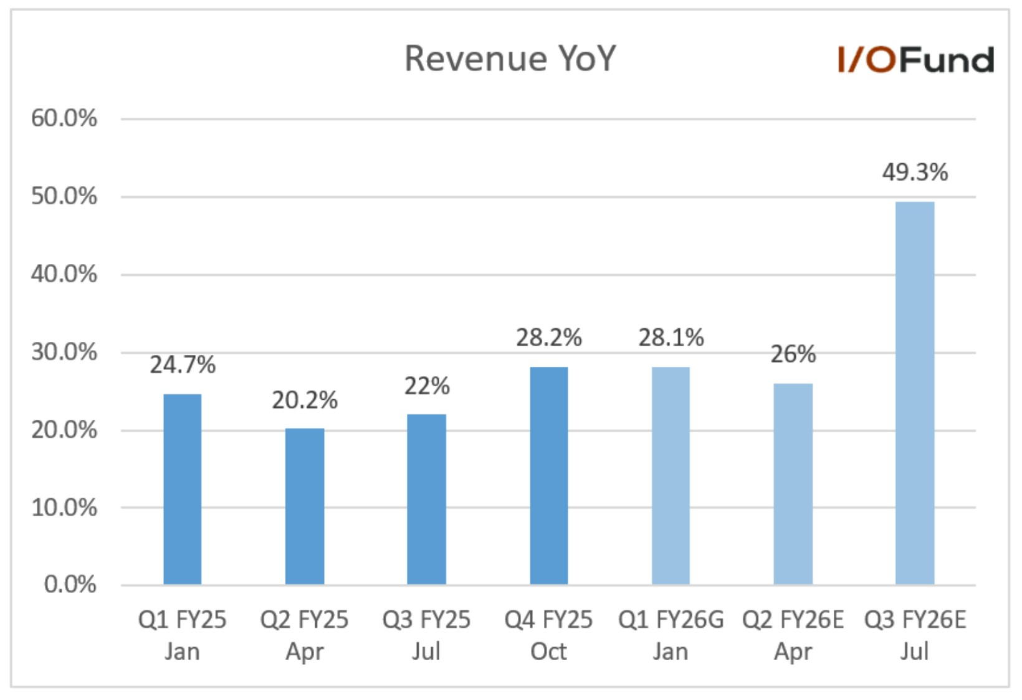
Management also provided a strong FQ1 revenue guide of $19.1 billion, implying a YoY growth of 28.1% and 6% QoQ, beating estimates by 4.3%. The expected strong growth is primarily driven by AI revenue, which is expected to double YoY to $8.2 billion. Analysts expect strong growth to continue, with revenue expected to grow 26% YoY to $18.91 billion in FQ2 and accelerating 49.3% YoY growth to $23.82 billion in FQ3.
For FY2025, ending October, revenue grew by 23.9% YoY to a record $63.89 billion. The strong growth was primarily driven by AI revenue and VMware. Looking forward, analysts expect revenue to grow 35.7% YoY to $86.1 billion in FY2026 and 33.1% YoY to $114.59 billion in FY2027.
Key Segments
Semiconductor Solutions
FQ4 semiconductor solutions revenue grew by 35% YoY to $11.07 billion, primarily driven by strong AI revenue. Revenue growth accelerated by 9 percentage points from 26% growth reported in FQ3. Management expects semiconductor revenue growth to further accelerate 15 percentage points to 50% YoY, reaching $12.3 billion in FQ1, driven by a surge in AI revenue. For FY2025, semiconductor revenue grew by 22% YoY to a record $36.9 billion.
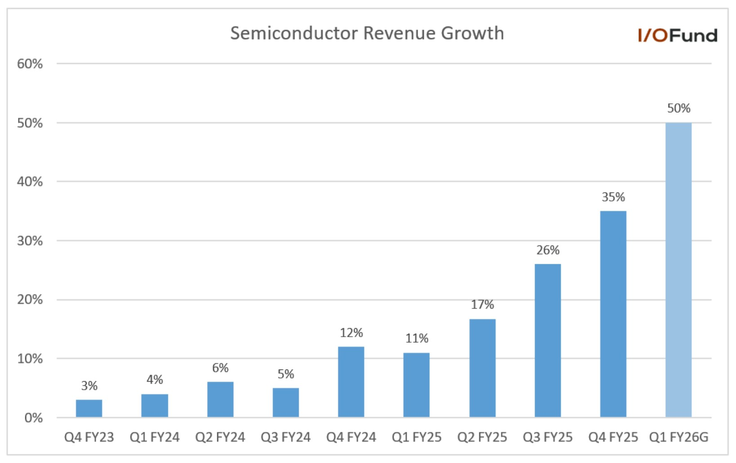
FQ4 AI revenue grew by 74% YoY and 25% QoQ to $6.5 billion and was higher than the management guide of $6.2 billion. CEO Hock Tan said in the earnings call, “And this represents a growth trajectory exceeding 10x over the 11 quarters we have reported this line of business. Our custom accelerated business more than doubled year-over-year, as we see our customers increase adoption of XPUs, as we call those custom accelerators in training their LLM and monetizing their platforms through inferencing APIs and applications.” It further highlights the point that we have discussed in our article here that Broadcom is a silent beneficiary of the AI Monetization trend.
Management also highlighted that these XPUs have also been extended to other LLMs, “best exemplified at Google, where the TPUs use in creating Gemini, have also been used for AI cloud computing by Apple, Coherent and SSI as an example. And the scale at which we see this happening could be significant.” Management confirmed that the $10 billion order from the fourth customer they mentioned in the last earnings call was from Anthropic and that they received an additional $11 billion order this quarter for delivery in late 2026. Broadcom also announced a fifth XPU customer this quarter, who has placed a $1 billion order to be delivered in late 2026.
Management also provided a strong AI revenue guide for FQ1 of $8.2 billion, implying a 100% YoY and 26% QoQ growth. The expected strong growth is primarily driven by custom AI accelerators and Ethernet AI switches. For the FY2025, AI revenue grew by 65% YoY to $20 billion. Management expects AI revenue to accelerate in FY2026 and drive most of Broadcom’s growth in FY2026.
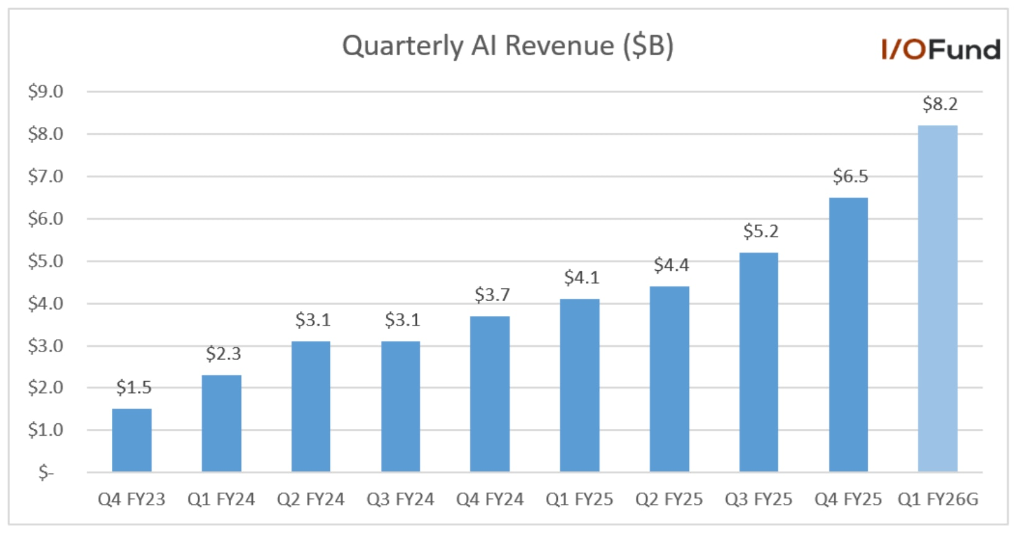
Non-AI semiconductor revenue in FQ4 grew by 2% YoY and 16% QoQ to $4.6 billion primarily driven by favorable wireless seasonality. As seen below, the gap between AI and non-AI revenue is widening as AI growth accelerates. Management expects non-AI-semiconductor revenue to be flat YoY to $4.1 billion and down sequentially in FQ1 due to wireless seasonality.
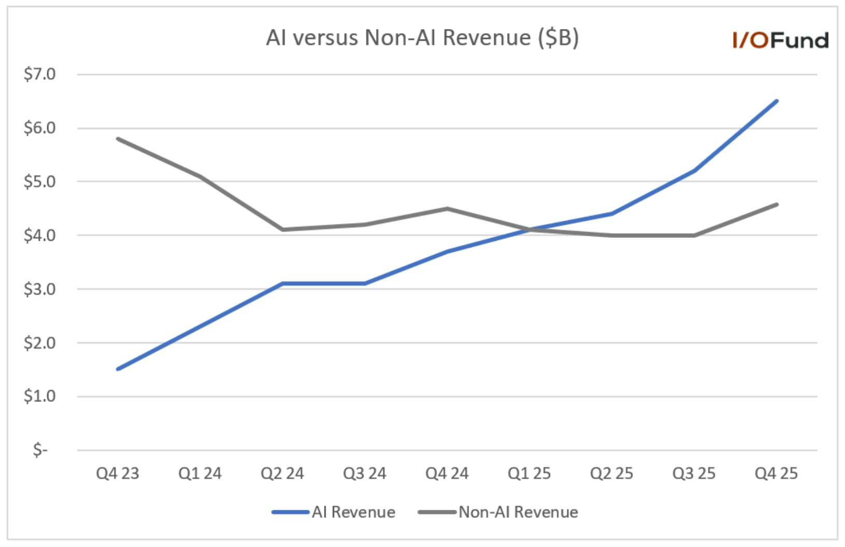
Infrastructure Software
FQ4 Infrastructure software revenue grew by 19% YoY to $6.9 billion, above the management guide of $6.7 billion. Bookings continue to be strong, with total contract value booked in FQ4 exceeding $10.4 billion compared to $8.2 billion in the same period last year.
The Infrastructure Software backlog was $73 billion compared to $49 billion in the same period last year. Management expects renewals to be seasonal in Q1 and expects Infrastructure Software revenue to be $6.8 billion, down (2%) sequentially and up 1% YoY.
For the FY2025, Infrastructure Software revenue grew by 26% YoY to $27 billion, primarily driven by strong VMware revenue. Management expects Infrastructure Software revenue to grow in the low double digits in FY2026.
Margins
Broadcom reported better margins than expected, primarily due to higher software revenue than expected, operating leverage, and better product mix within the semiconductor revenue. As discussed earlier in our article that AI revenue will lead to lower gross margin in the coming quarters. However, management was clear that gross profit dollars and operating income dollars will continue to rise due to scale and operating leverage.
- FQ4 gross profits grew by 36.1% YoY to $12.25 billion, with a gross margin of 68%, an improvement of 390 basis points YoY and 90 basis points sequentially. Adjusted gross margin was 77.9%, up 100 basis points YoY and down 50 basis points sequentially. It was better than the management guidance of 77.7% primarily due to higher software revenues than expected and better product mix within semiconductors. Management expects FQ1 adjusted gross margin to be down 100 basis points sequentially to 76.9% primarily due to higher mix of AI revenue.
- FQ4 operating income grew by 62.3% YoY to $7.5 billion. Operating margin improved 8.8 percentage points YoY and 4.8 percentage points sequentially to 41.7%, primarily driven by operating leverage. The adjusted operating margin was 66.2%, compared to 62.7% in the same period last year and 65.5% in the previous quarter.
- Net income grew by 102.6% YoY to $8.5 billion with net profit margin of 47.3% compared to 30.8% in the same period last year. Adjusted net income grew by 39.5% YoY to $9.7 billion, with an adjusted net profit margin of 53.9% compared to 49.6% in the same period last year.
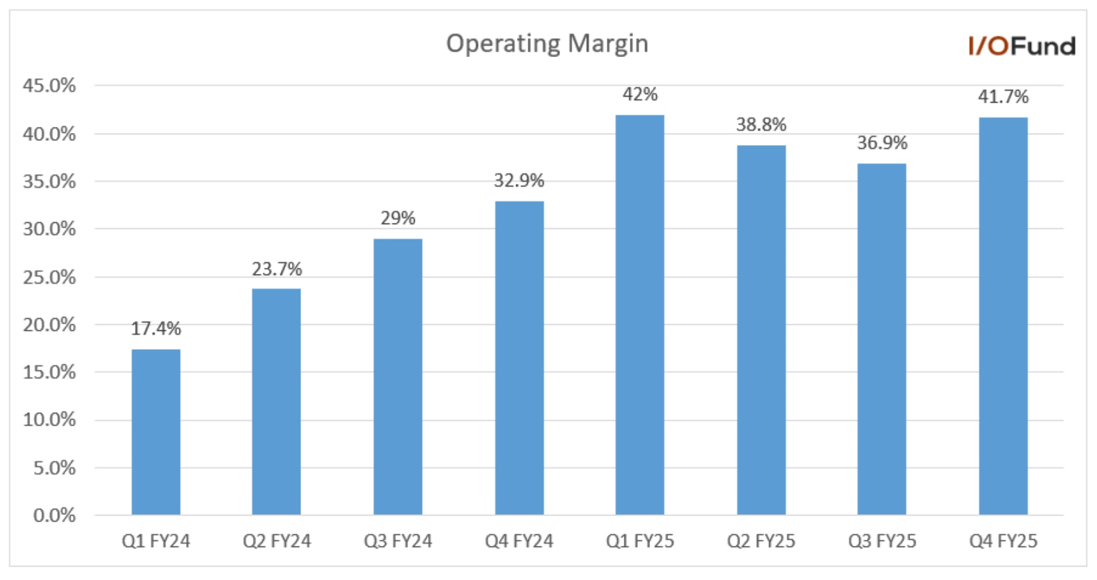
FQ4 adjusted EBITDA grew by 34.4% YoY to $12.2 billion with an adjusted EBITDA margin of 68% and was better than the management guide of 67%. For FQ1, management expects adjusted EBITDA margin to be down 100 basis points sequentially and YoY to 67%.
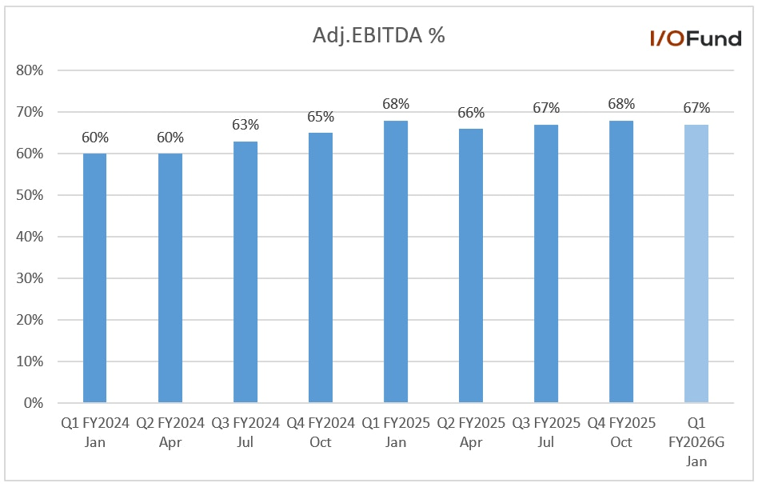
- For FY2025 gross margins came at 67.8%, an improvement of 480 basis points YoY. Similarly, operating margin improved by 13.8 percentage points to 39.9%. The adjusted EBITDA margin was 67% compared to 62% last year.
Adjusted EPS grew by 37%
FQ4 GAAP EPS grew by 93.3% YoY to $1.74. While adjusted EPS grew by 37.3% YoY to $1.95, beating estimates by 4.3%. Analysts expect adjusted EPS to grow by 23.3% YoY to $1.97 in FQ1 and 28.7% YoY to $2.03 in FQ2.
Strong adjusted EPS is expected to continue in the coming years and analysts expect FY2026 adjusted EPS to grow by 39.1% YoY to $9.39 and 35.6% YoY to $12.72 in FY2027. However, these estimates are conservative, as the ramp-up of recent deals is expected to provide a further boost to the bottom line in the long term.
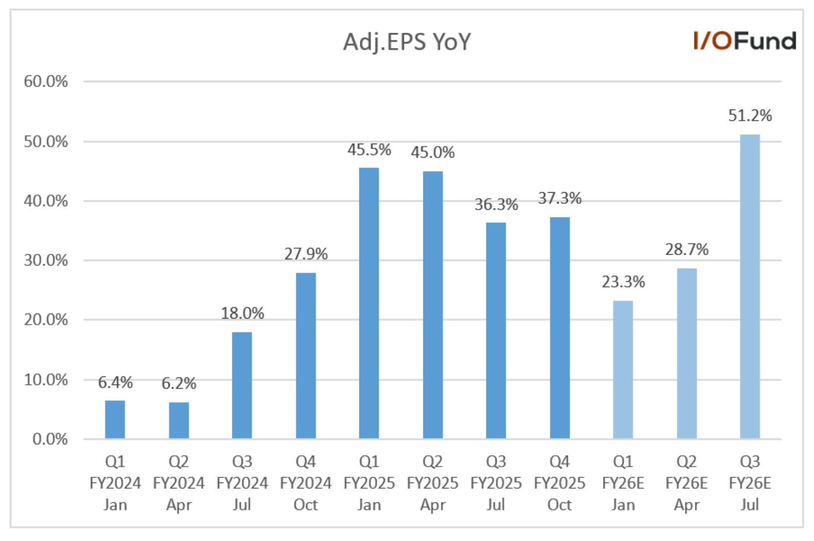
Cash Flow and Balance Sheet
Broadcom’s cash flows are improving, driven by higher profits.
- FQ4 operating cash flows grew by 37.5% YoY to $7.70 billion with an operating cash flow margin of 42.8% compared to 39.9% in the same period last year.
- FQ4 free cash flows grew by 36.2% YoY to $7.47 billion with a free cash flow margin of 41.4% compared to 39% in the same period last year.
- Cash was $16.18 billion at the end of FQ4 with debt of $65.1 billion compared to $10.7 billion cash and debt of $64.2 billion at the end of FQ3; cash increased due to higher free cash flows in the recent quarter.
- Management also increased the quarterly dividend by 10% to $0.65 or $2.60 for FY2026.
- Inventory grew by 4% sequentially to $2.3 billion in FQ4.
Conclusion:
Broadcom provided a solid report with no red flags to speak of. The AI cycle is approaching an inflection point, as a technology long debated will finally begin to move toward monetization, which will be a defining moment for the markets. If I had to guess, after listening closely to the management teams on the front lines, we will see major progress on inference in 2026 with more economic impact in 2027-2028.
That makes 2025 the AI crux as many companies are spending an ungodly amount on building AI infrastructure with little immediate return on investment. When revenue and profits begin to catch up to these investments, the impact could be significant. I believe Broadcom will have a front row seat for that moment.

